**Need for Online Analytical Processing (OLAP):**

OLAP→efficient data analysis and informed decision-making processes within organizations.

1. Facilitates detailed analysis of large and complex datasets.
2. Supports interactive exploration, uncovering trends and patterns.
3. Enables timely decision-making with up-to-date data.
4. Provides business intelligence through interactive reports and visualizations.
5. Allows ad hoc analysis for spontaneous insights.
6. Aids in predicting future trends and outcomes.
7. Supports decision-makers by presenting actionable information.

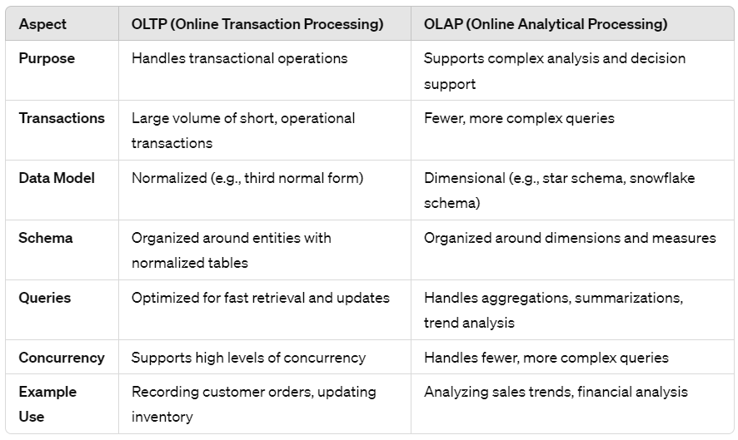

**OLAP, or Online Analytical Processing**, is a technology used to organize large business databases and facilitate complex analysis.

*OLAP* systems enable users to interactively analyze multidimensional data stored in DWs or data marts. They let you analyze a bunch of different types of data all at once. They provide fast query response times and support complex analytical queries.

*Multidimensional analysis* involves analyzing data from different perspectives, users can gain deeper insights into business performance, trends, and patterns. Instead of just looking at one aspect, like sales numbers, you can look at lots of factors together, like where the sales happened, who made them, and when they happened. This helps you see a more complete picture of what's going on.

*Multidimensional Data Model:* In OLAP, data is organized into a multidimensional data model, represented as a data cube. This model consists of dimensions, measures, and hierarchies. Dimensions represent the various attributes by which data can be analyzed, while measures are the numerical values being analyzed. Hierarchies represent the relationships between different levels of each dimension.

**OLAP Operations in Multidimensional Data Model:**

1. *Roll-up (Drill-up):*

This operation involves summarizing data by moving up the hierarchy of a dimension. It's like zooming out to see broader categories or summaries of data.

Ex., if you're looking at sales data, rolling up from monthly sales to yearly sales would give you a bigger-picture view of the overall sales performance for the year.

1. *Drill-down (Roll down):* Opposite of roll-up. Moving from summarized data to more detailed data by moving down hierarchy of a dimension. Zooming in to see more specific details. Ex., drilling down from yearly → quarterly sales = provide more detailed insights into sales trends within each quarter.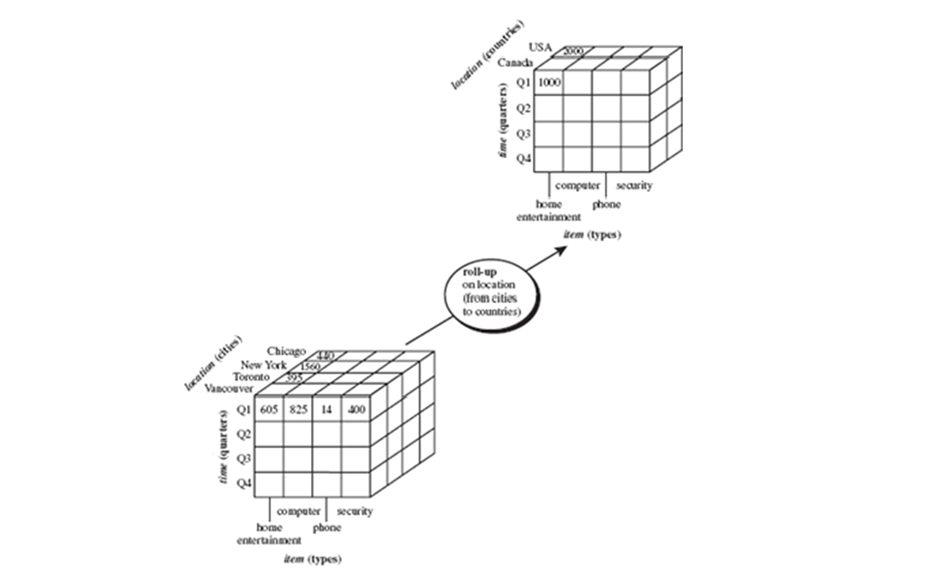
2. *Slice and Dice:*

*Slice:* Select a specific part of the data along one dimension, creating a subset of data, like looking at a specific slice of data.

*Dice:* Similar to slice but involves selecting a specific part of the data by slicing along multiple dimensions. It allows for a more refined subset of the data.

Ex, you're analyzing sales data, you might slice the data to look at sales only for a particular region or time period, or dice data to examine sales for a specific product in a certain region & time frame.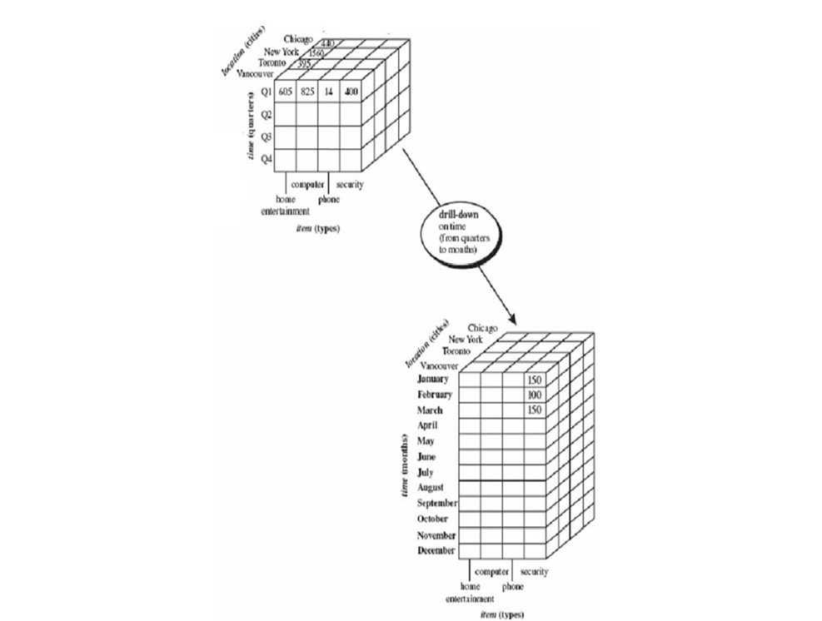

1. *Pivot (Rotate):*

The pivot operation changes the way data is presented by rotating the axes. It allows you to view the data from different perspectives or dimensions, providing alternative presentations of the data.

For example, you could pivot the data to switch the rows and columns, which might offer a clearer view of the relationships between different variables or dimensions.

1. *Drill-across:*

Querying data from multiple sources simultaneously. Helps analyze different aspects together for a complete view.

Example: Studying sales data alongside customer demographics to see sales trends across different customer groups.

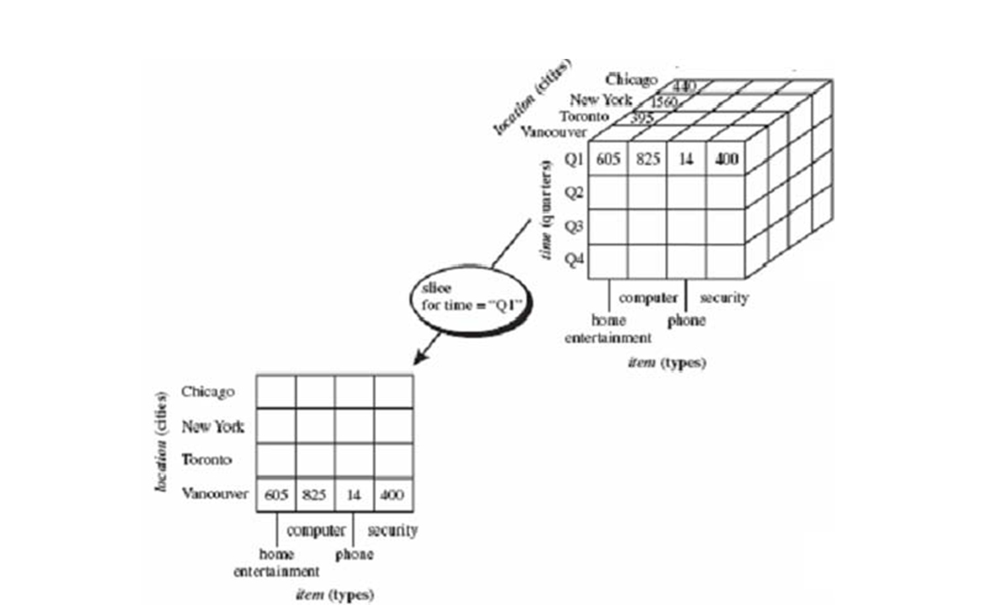

1. *Drill-through:*

Access detailed data stored in underlying relational db from summarized data in OLAP cube. Allows to drill down to raw, detailed data behind the summarized information in the cube.

For example, if you're looking at summarized sales data in the OLAP cube, drill-through would enable you to access the individual transactions or records that make up those sales figures, providing a more granular level of detail.

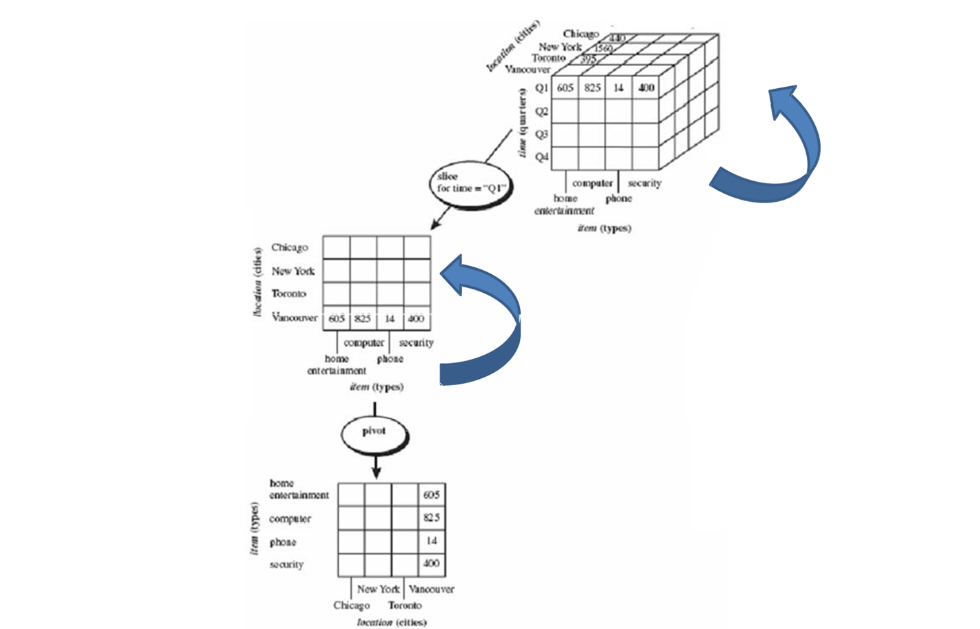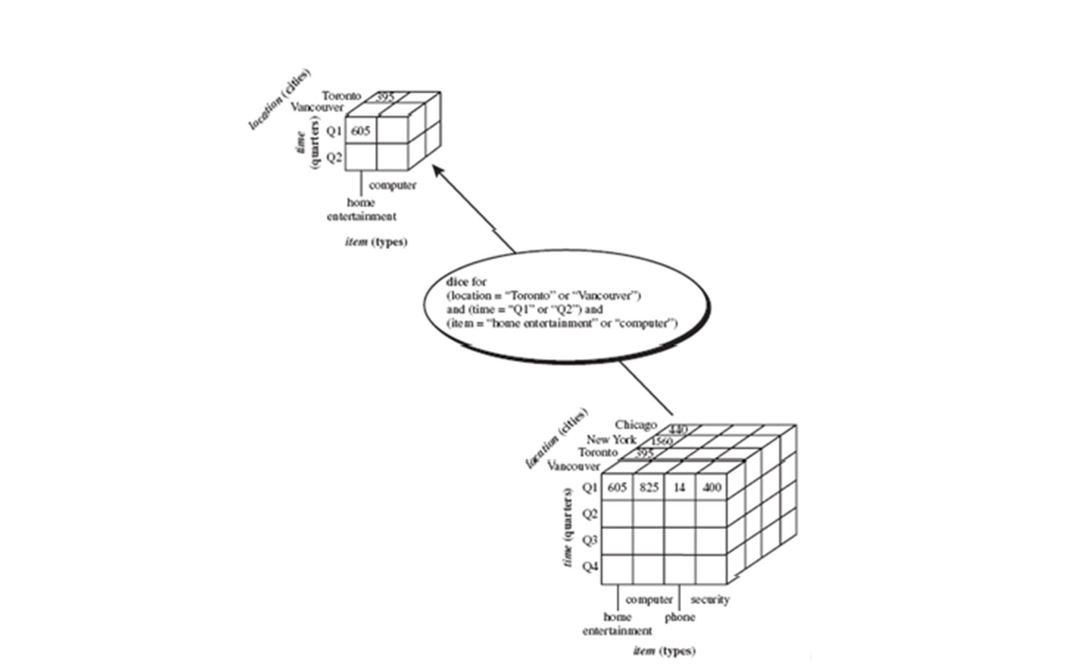

**OLAP Server Architectures:**

1. *Relational OLAP (ROLAP):*

Used for data stored in a relational db, where both the base data & dimension tables are stored as relational tables. Used to bridge the gap between the relational back-end server and the client’s front-end tools. ROLAP servers store and manage warehouse data using RDBMS, and OLAP middleware fills in the gaps.

Advantages: Handles large amounts of data well. Can use built-in features of relational dbs.

Disadvantages: Performance can be slow. Limited by the capabilities of SQL (the language used to interact with relational databases). It’s difficult to keep aggregate tables up to date.

1. *Multidimensional OLAP (MOLAP):*

Uses array-based storage to handle multidimensional views of data. Data is stored in a specialized multidimensional array structure on disks. Unlike ROLAP, which only stores non-zero data, MOLAP defines all array elements, making arrays sparse with many empty cells. MOLAP cubes are great for analyzing data and performing complex calculations.

Advantages: Offers excellent performance. Can perform complex calculations efficiently. Suitable for slicing and dicing operations. Outperforms ROLAP when data is dense.

Disadvantages: Requires additional investment in specialized software. Since all calculations are performed when the cube is built, a large amount of data cannot be stored in cube itself.

1. *Hybrid OLAP (HOLAP):*

It combines ROLAP and MOLAP. It offers the scalability of ROLAP and the fast computation of MOLAP. HOLAP servers store large amounts of detailed data and use cube technology for quicker performance. Unlike MOLAP, HOLAP stores detailed data in relational databases, making cubes smaller and more efficient.

Benefits: MOLAP+ROLAP. Provide quick access at all aggregation levels.

Limitations: Because it supports both MOLAP and ROLAP servers, HOLAP architecture is extremely complex. There is a greater likelihood of overlap, particularly in their functionalities.